WEEK-1
Exercise 1: Setting Up JUnit Scenario: You need to set up JUnit in your Java project to start writing unit tests. Steps: 1. Create a new Java project in your IDE (e.g., IntelliJ IDEA, Eclipse). 2. Add JUnit dependency to your project. If you are using Maven, add the following to your pom.xml: junit junit 4.13.2 test 3. Create a new test class in your project.
To set up JUnit in your Java project to start writing unit tests, you must update your Maven configuration.
File: pom.xml (located in the root of your project)
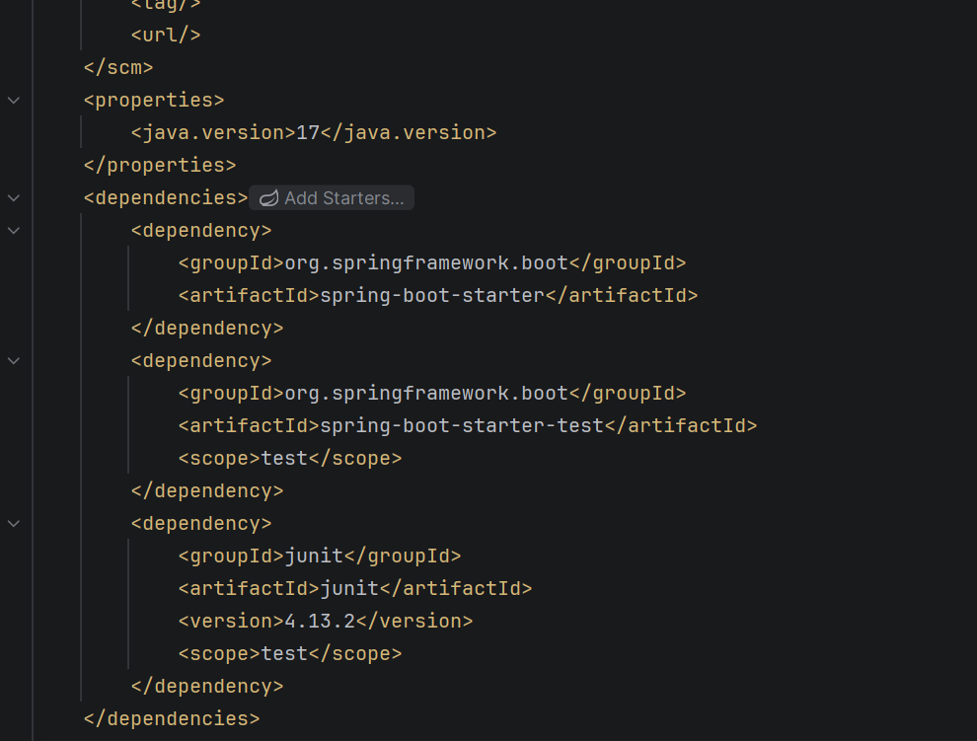

Exercise 3: Assertions in JUnit Scenario: You need to use different assertions in JUnit to validate your test results. Steps: 1. Write tests using various JUnit assertions
File 1 (Source Code): src/main/java/com/cognizant/Calculator.java
package com.cognizant;
public class Calculator {
public int add(int a, int b) {
return a + b;
}
}
File 2 (Test Code): src/test/java/com/cognizant/CalculatorTest.java
package com.cognizant;
import org.junit.Test;
import static org.junit.Assert.assertEquals;
public class CalculatorTest {
@Test
public void testAdd() {
Calculator calc = new Calculator();
int result = calc.add(10, 5);
assertEquals(15, result);
}
}

Exercise 4: Arrange-Act-Assert (AAA) Pattern, Test Fixtures, Setup and Teardown Methods in JUnit Scenario: You need to organize your tests using the Arrange-Act-Assert (AAA) pattern and use setup and teardown methods. Steps: 1. Write tests using the AAA pattern. 2. Use @Before and @After annotations for setup and teardown methods.
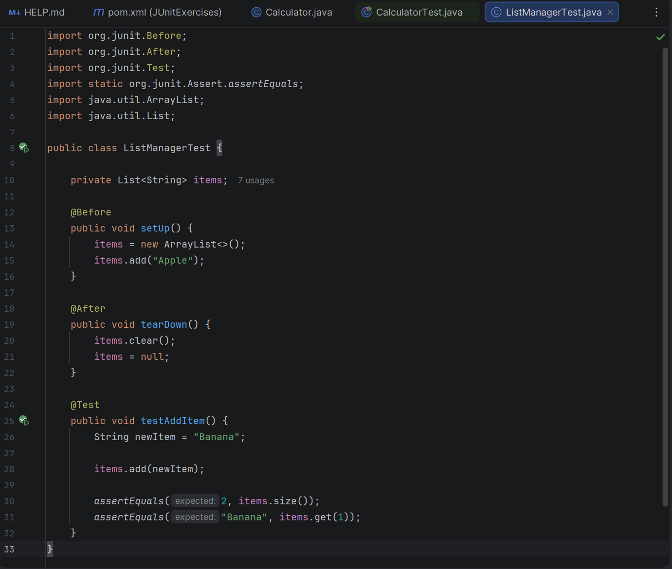
Execution Result:
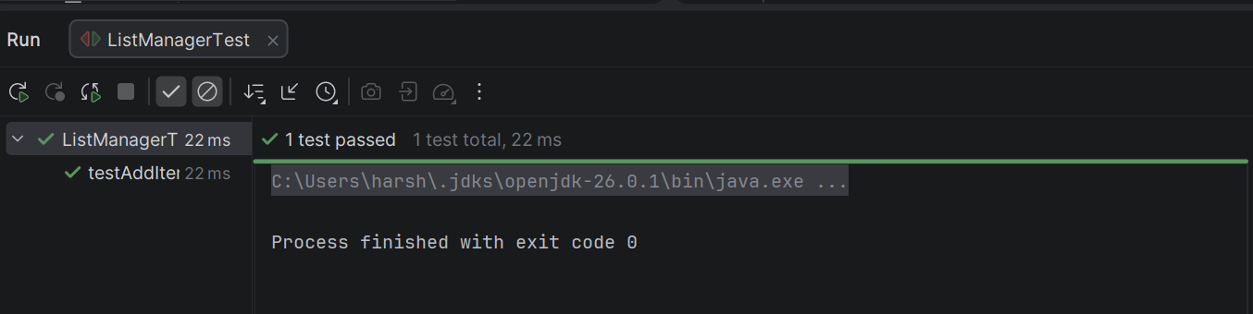

MOCKITO EXERCISES
Exercise 1: Mocking and Stubbing Scenario: You need to test a service that depends on an external API. Use Mockito to mock the external API and stub its methods. Steps: 1. Create a mock object for the external API. 2. Stub the methods to return predefined values. 3. Write a test case that uses the mock object.

Exercise 2: Verifying Interactions Scenario: You need to ensure that a method is called with specific arguments. Steps: 1. Create a mock object. 2. Call the method with specific arguments. 3. Verify the interaction.

1. ExternalApi.java
Location: src/main/java/ExternalApi.java
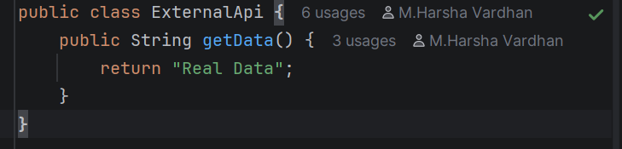
2. MyService.java
Location: src/main/java/MyService.java
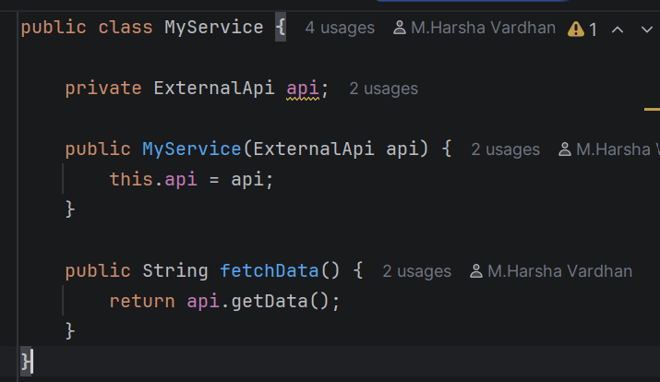

3. MyServiceTest.java
Location: src/test/java/MyServiceTest.java
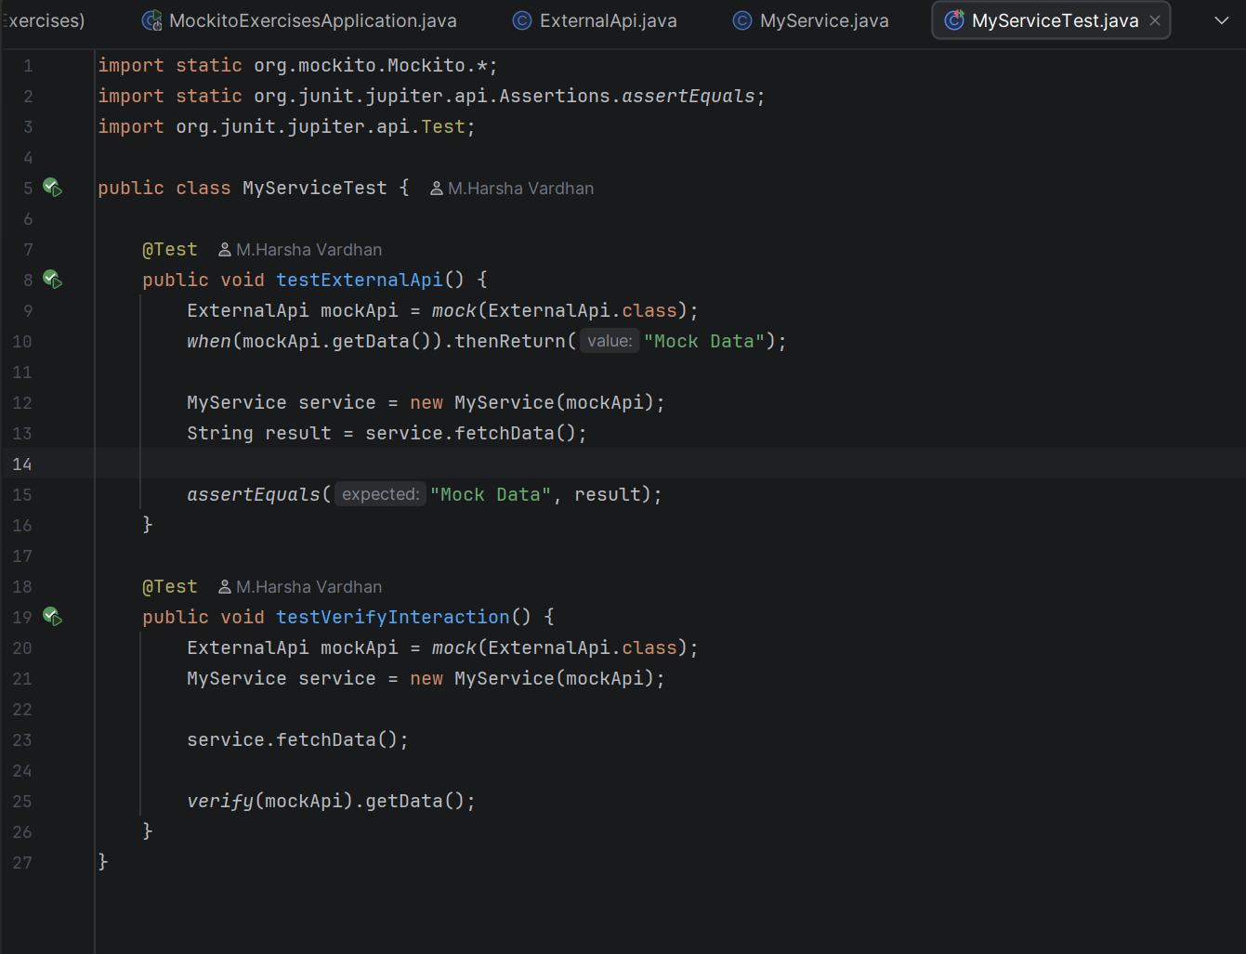

EXECUTION RESULT:
